Name: Astha Arpit Bhatt

Enroll: 196140316006

Practical-5

Aim: Develop an applet that contains one button. Initialize the label on the button to “start”, when the user presses the button, which changes the label between these two values each time the button is pressed

Code:

import java.awt.\*;

import java.awt.event.\*;

import java.applet.\*;

/\*<applet code="pra5" height=500 width=500></applet>\*/

public class pra5 extends Applet implements ActionListener

{

Button b;

public void init()

{

b=new Button("Start");

b.addActionListener(this);

add(b);

}

public void actionPerformed(ActionEvent ae)

{

String label=b.getLabel();

if(label.compareTo("Start")==0)

{

b.setLabel("Stop");

}

else

{

b.setLabel("Start");

}

}

}

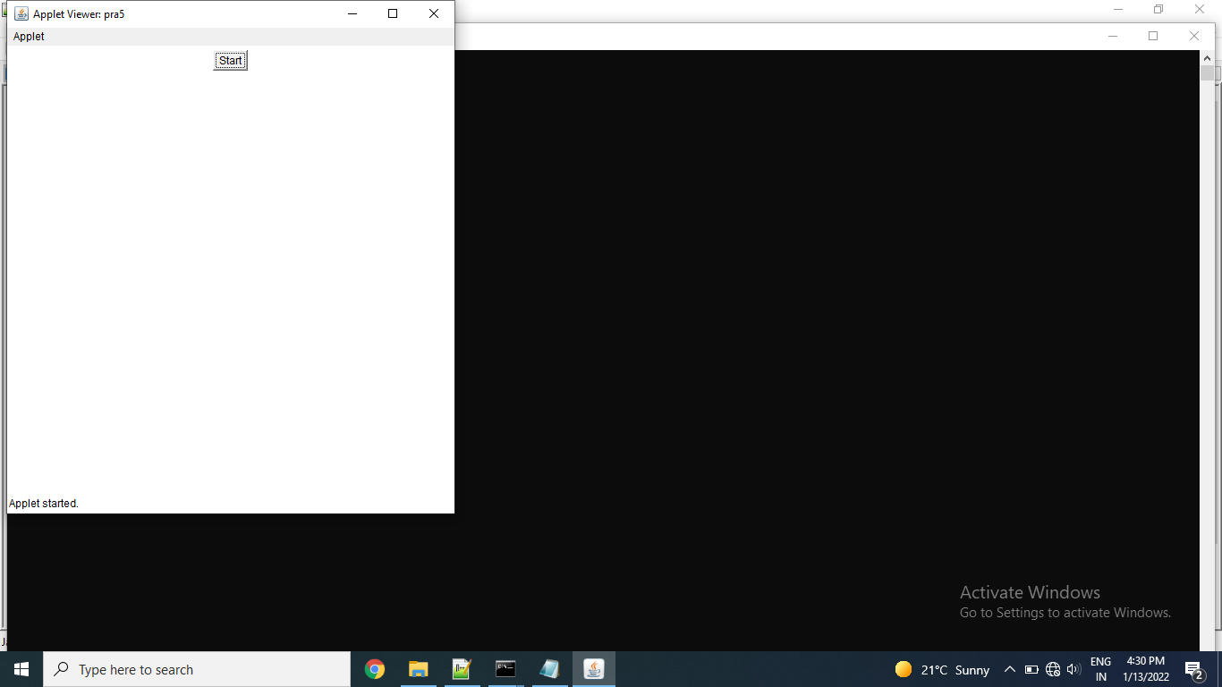

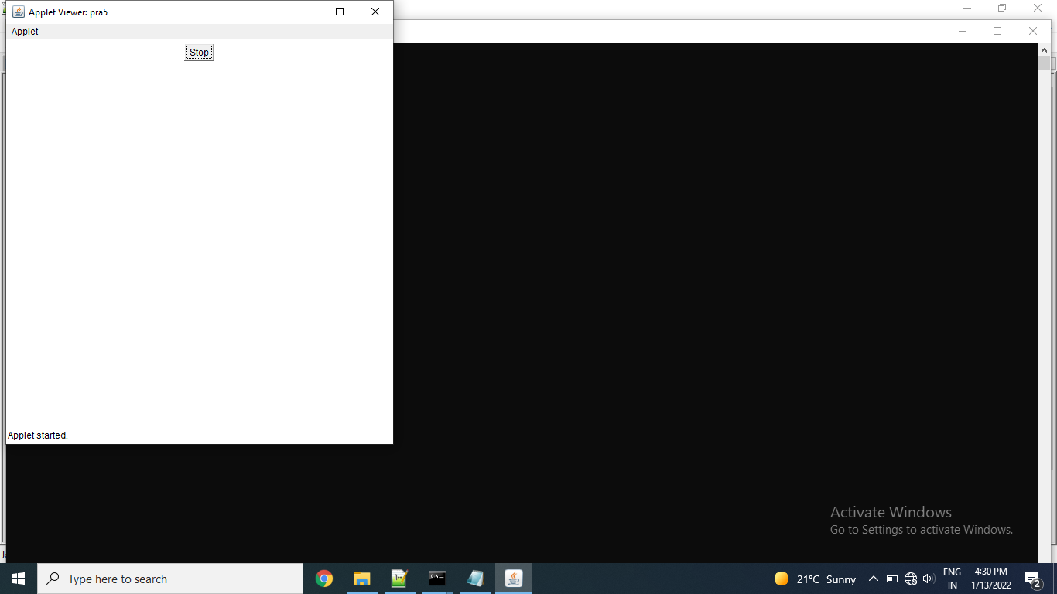

Exercise:

Develop an applet that contains two buttons. Initialize the label on the buttons to “red” and “green”, when the user presses the button, it should change the content on the label according to the button pressed.

Code:

import java.applet.\*;

import java.awt.\*;

import java.awt.event.\*;

/\*<applet code = "pra5e1.class" width = "500" height= "300" ></applet>\*/

public class pra5e1 extends Applet

{

TextField tf1=new TextField(15);

Button b1=new Button("RED");

Button b2=new Button("GREEN");

public void init()

{

add(tf1);

add(b1);

add(b2);

}

public boolean action(Event evt,Object obj)

{

if(evt.target.equals(b1))

{

getAppletContext().showStatus("red");

tf1.setText("RED");

}

if(evt.target.equals(b2))

{

getAppletContext().showStatus("green");

tf1.setText("GREEN");

}

return true;

}

}

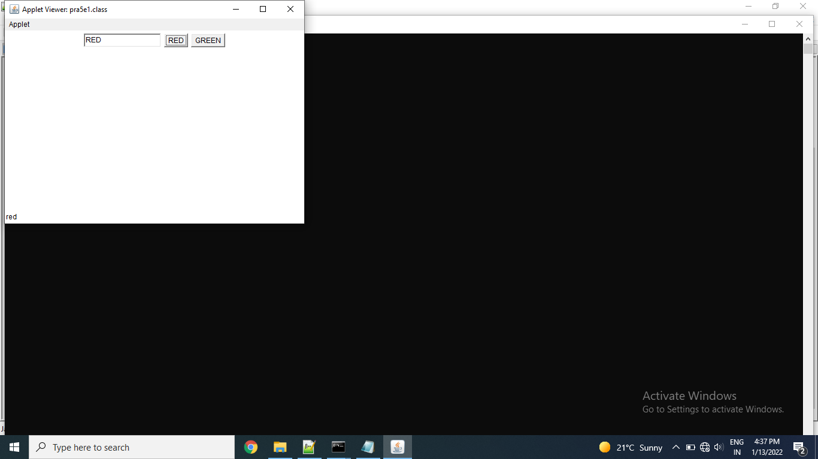

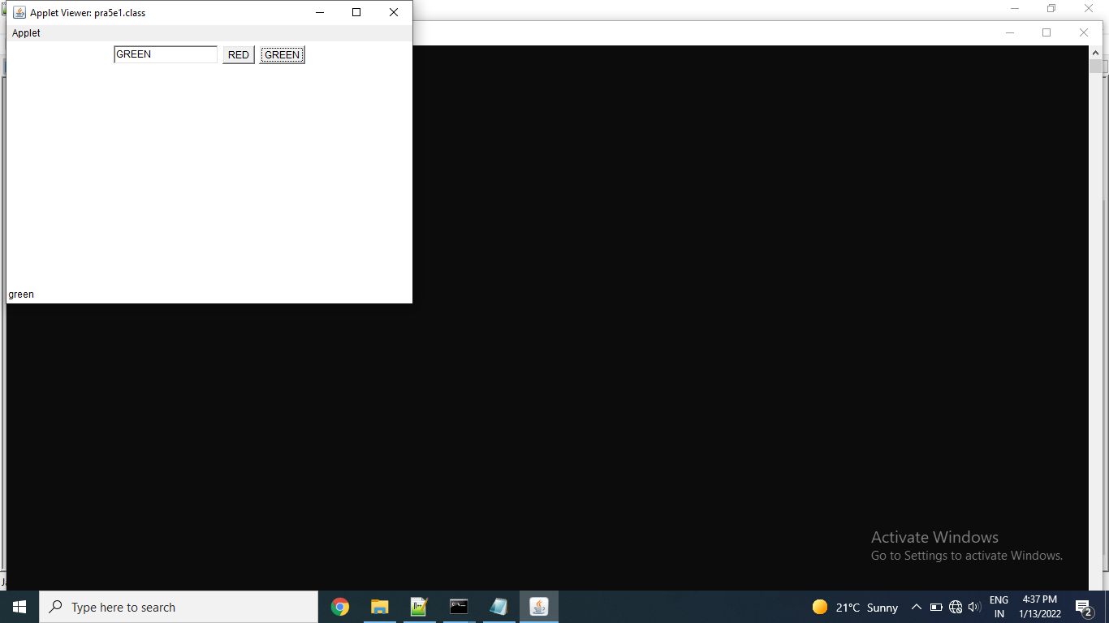

Thanks mam!!